Table of Contents

New users can register in the application after completely filling the form 2

Users are required to completely fill the register form 2

Email validation for the given email 2

Customers can login to their account using a validated email address 2

Attemp to login with wrong empty email or password 2

Attemp to login with wrong email address 2

Attemp to login with wrong password 2

Users can view products in the shop tab 2

Users can filter the products from the product filter 2

Users can search for required products using the search panel 2

Users can sort the products as shown 2

Users can add products to their basket 2

Users can update the quantity of products in the basket 2

Users can delete the product from the basket 2

Customers can view the basket with products and their summary 2

Customers can make payment for the whole basket at once 2

Customers will receive a reciept of payment for their goods in their email once payment is confirmed 2

## New users can register in the application after completely filling the form

Expected Result: The user is registered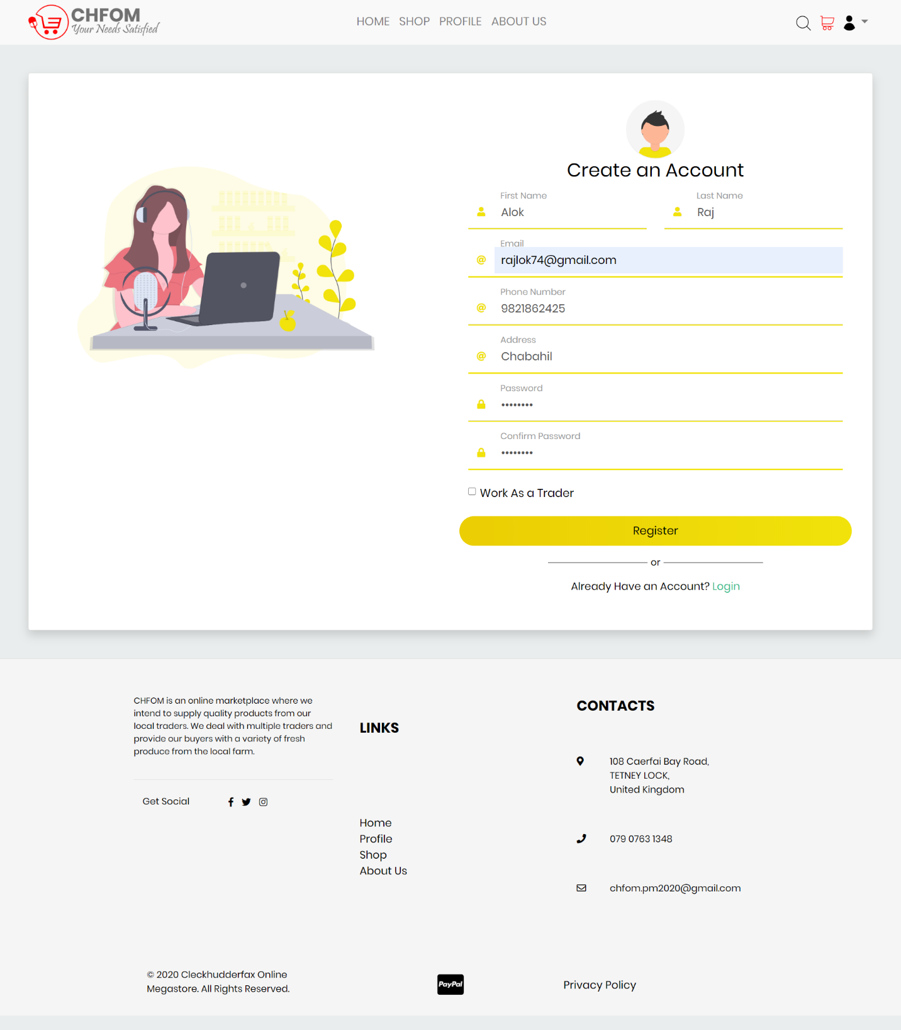

## Users are required to completely fill the register form

Expected Result: If form is incomplete, show error message

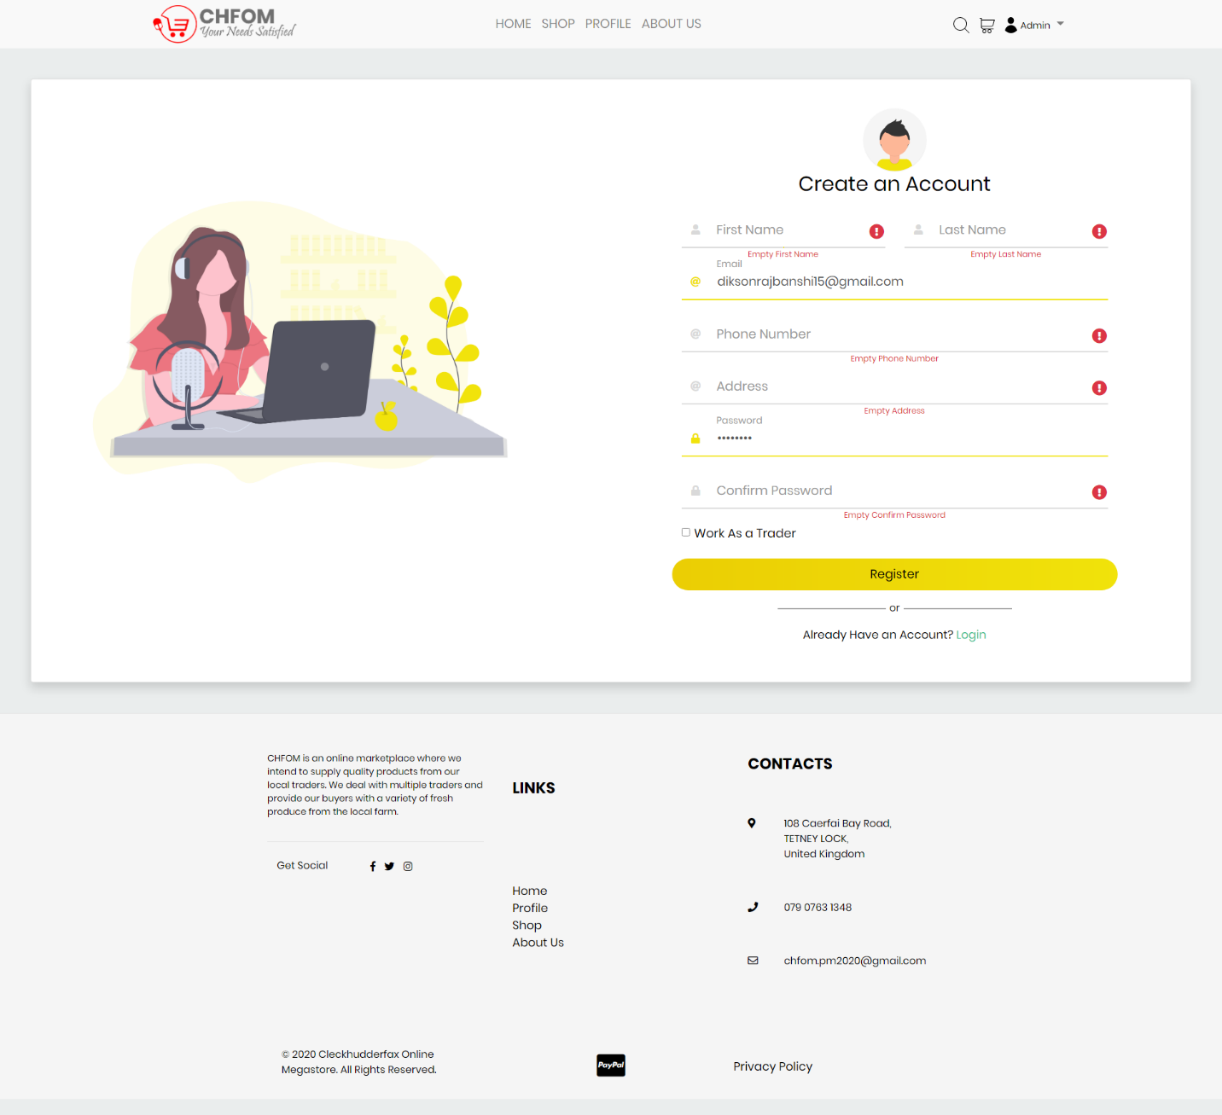

## Email validation for the given email

Expected Result: The user receives an email using which they can validate their email address

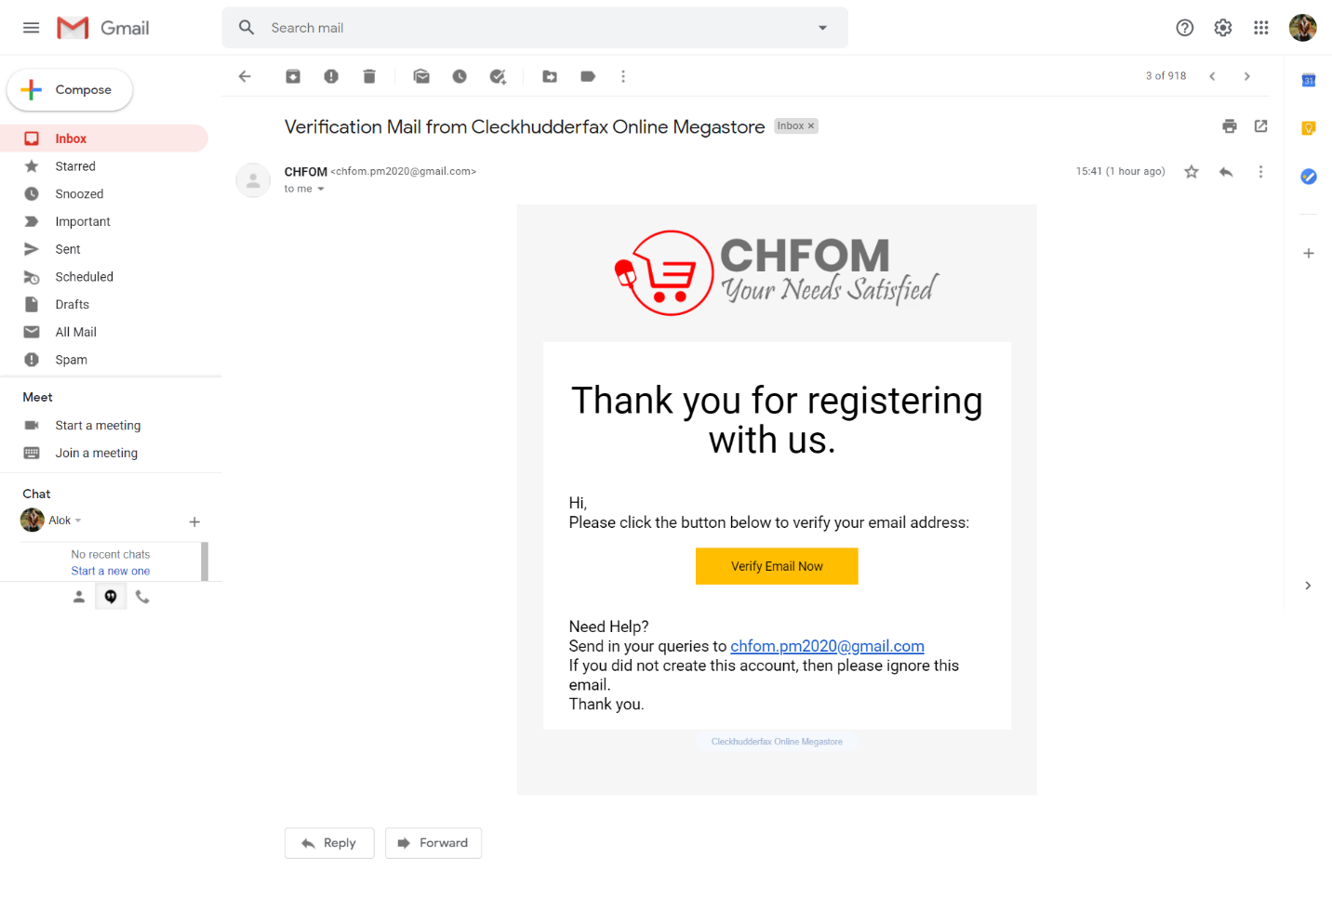

## Customers can login to their account using a validated email address

Expected Result: The user is logged in

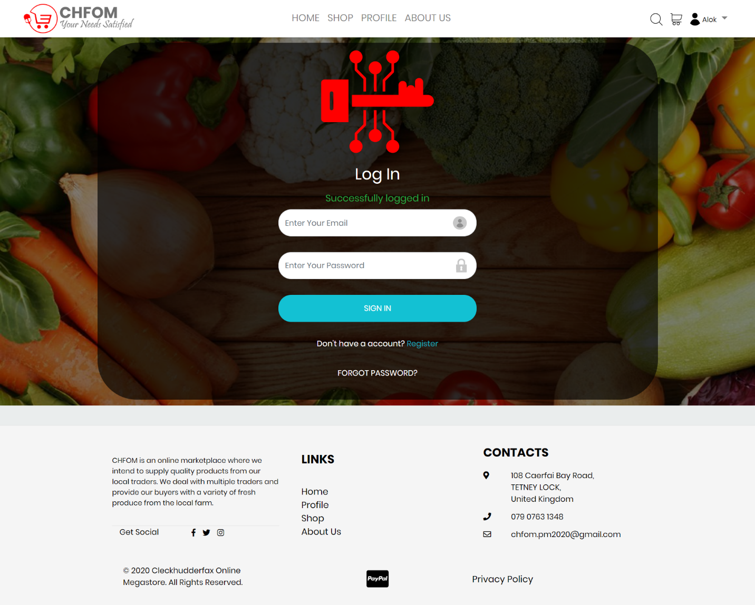

## Attempt to login with wrong empty email or password

Expected Result: An error message is shown asking user to fill all the information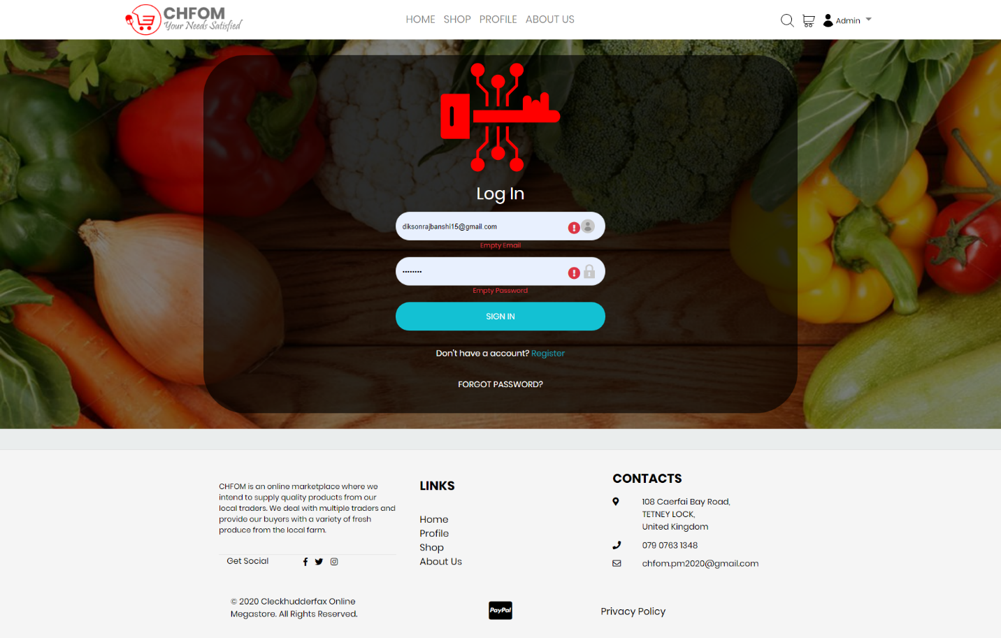

## Attempt to login with wrong email address

Expected Result: An error message showing wrong email is shown

## 

## Attempt to login with wrong password

Expected Result: An error message is shown informing the user of wrong password used



## Users can view profile details

Expected Result: Profile details are shown

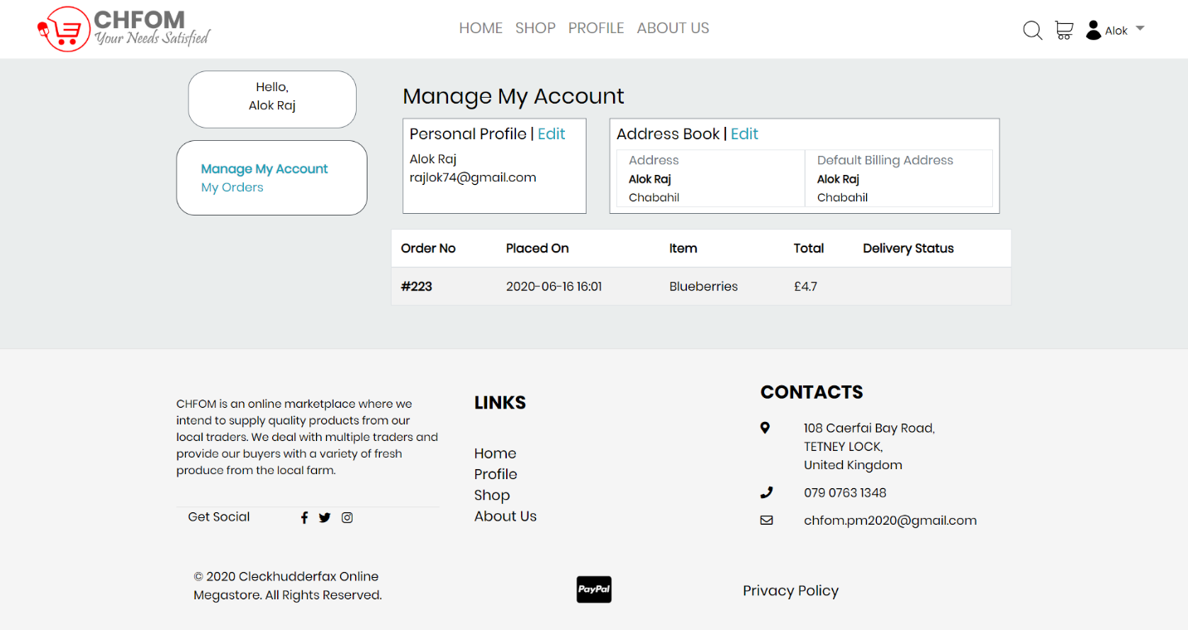

## Users can update profile with email confirmation

Expected Result: Profile is updated with email sent

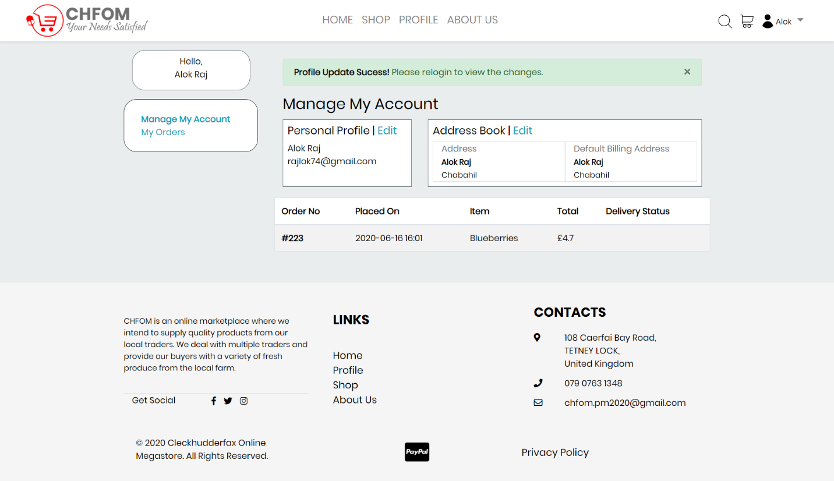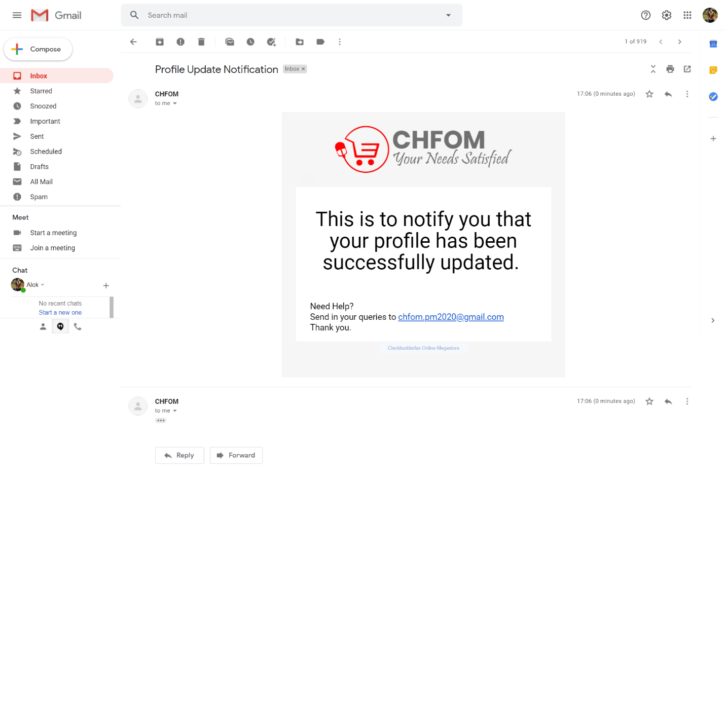

## Users can view products in the shop tab

Expected Result: Products are shown

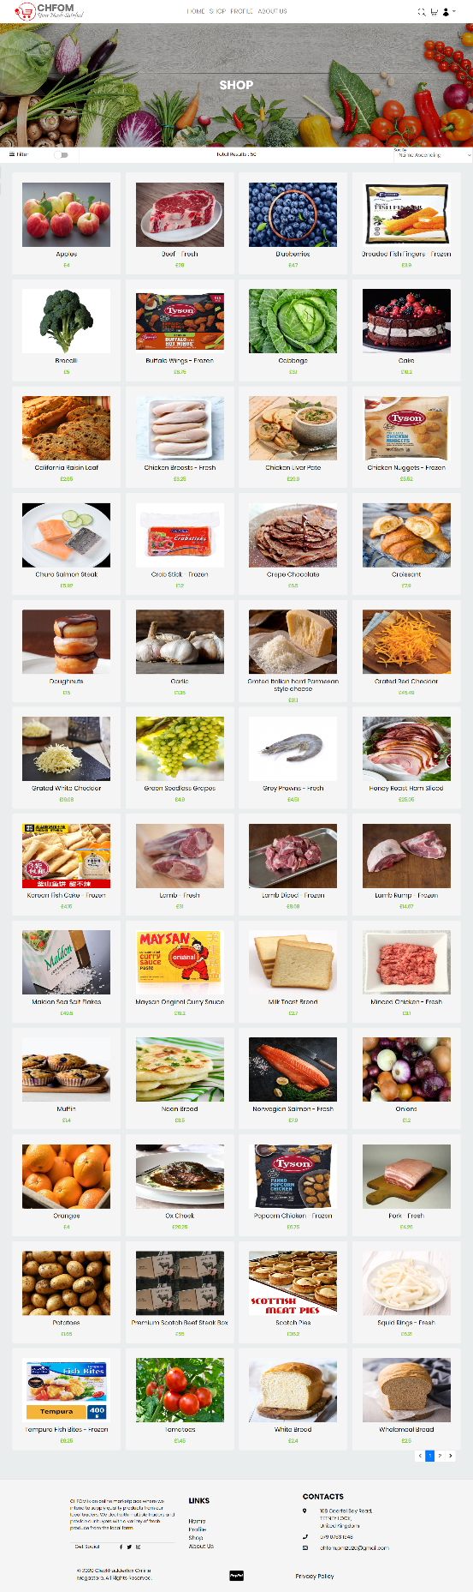

## Users can filter the products from the product filter

Expected Result: Filtered products are shown

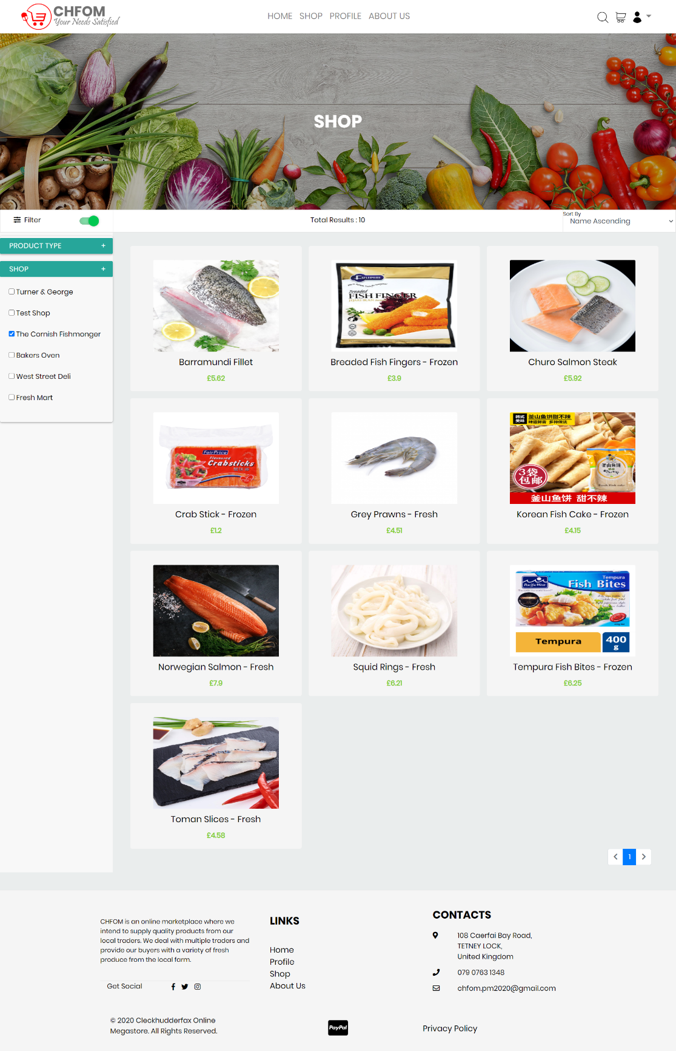

## Users can search for required products using the search panel

Expected Result: Matched products are shown in the search panel

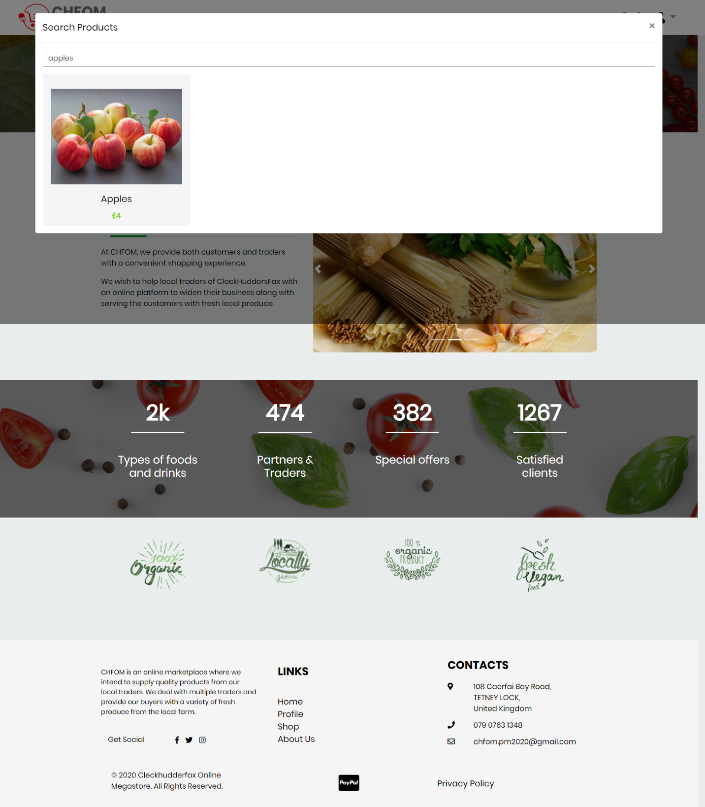

## Users can sort the products as shown

Expected Result: Products in sorted order are shown

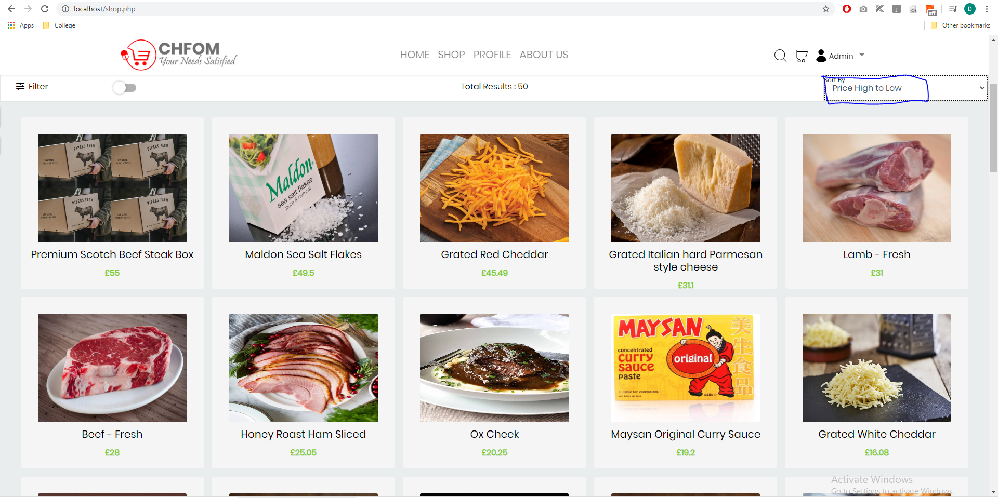

## Users can add products to their basket

Expected Result: Product is added to the basket

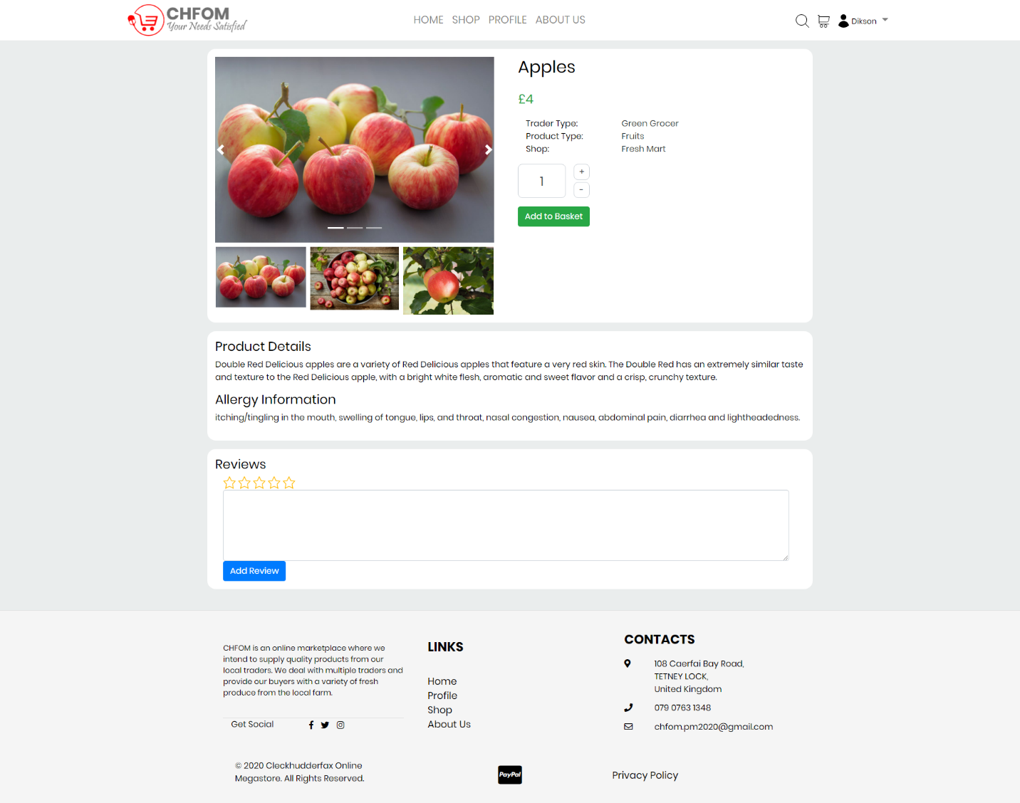

## Users can update the quantity of products in the basket

Expected Result: Product quantity is updated

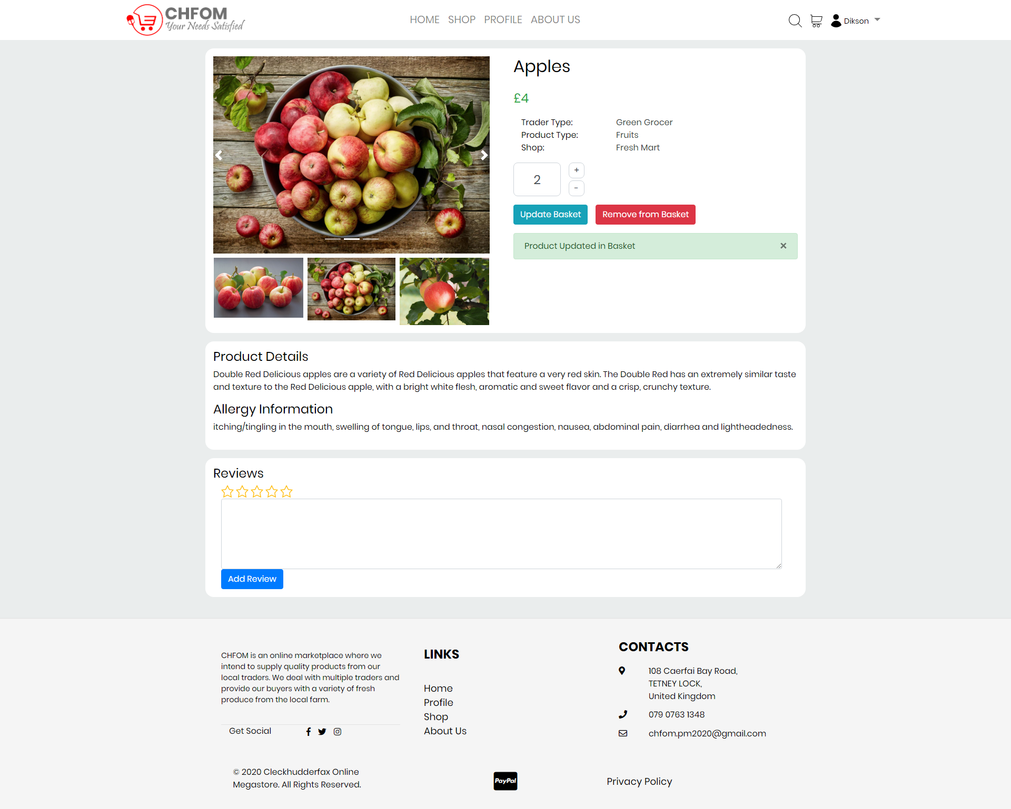

## Users can delete the product from the basket

Expected Result: Product is removed from the basket

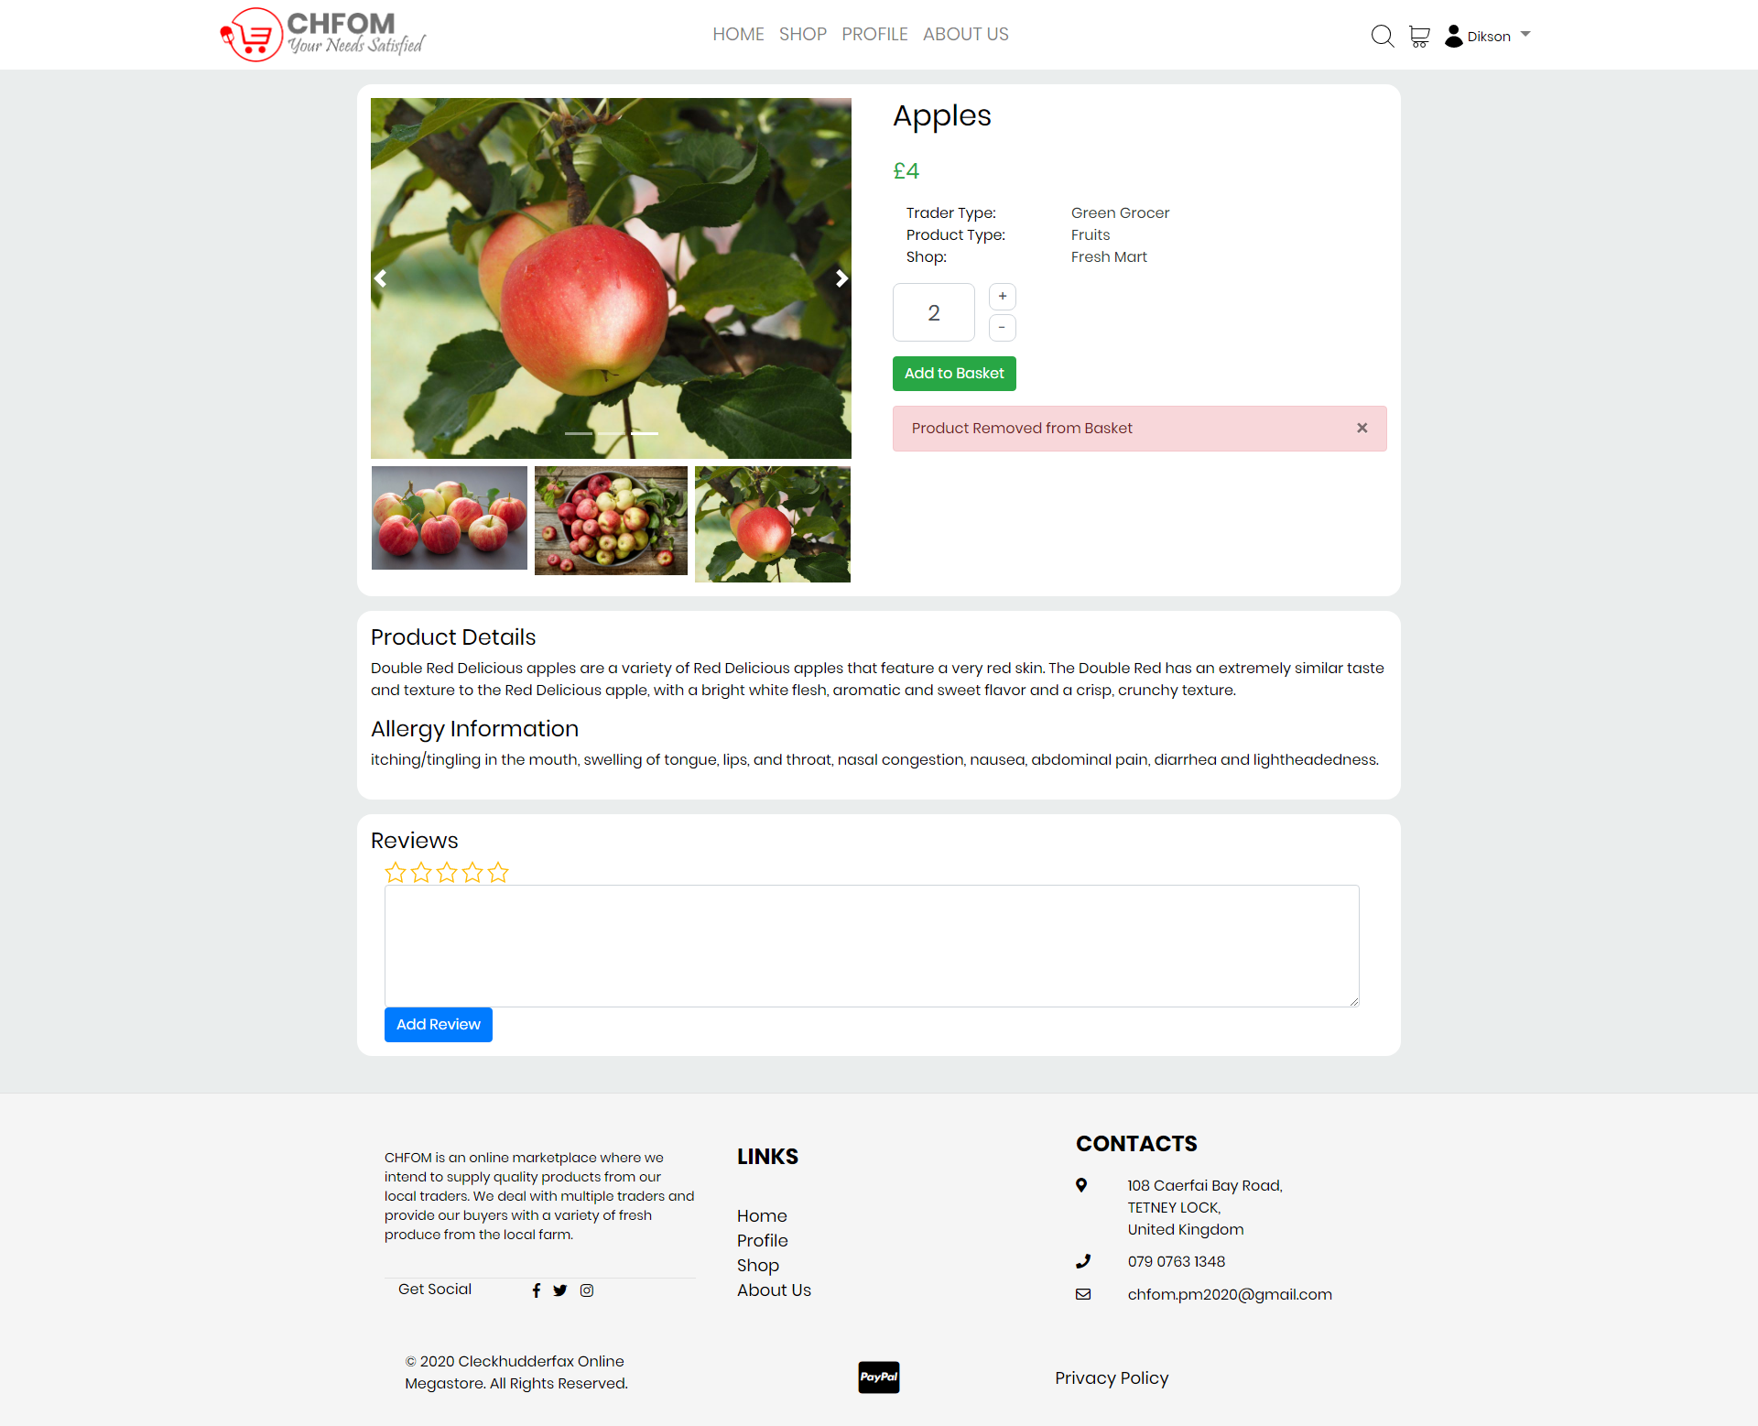

## Customers can view the basket with products and their summary

Expected Result: Basket with required details is shown

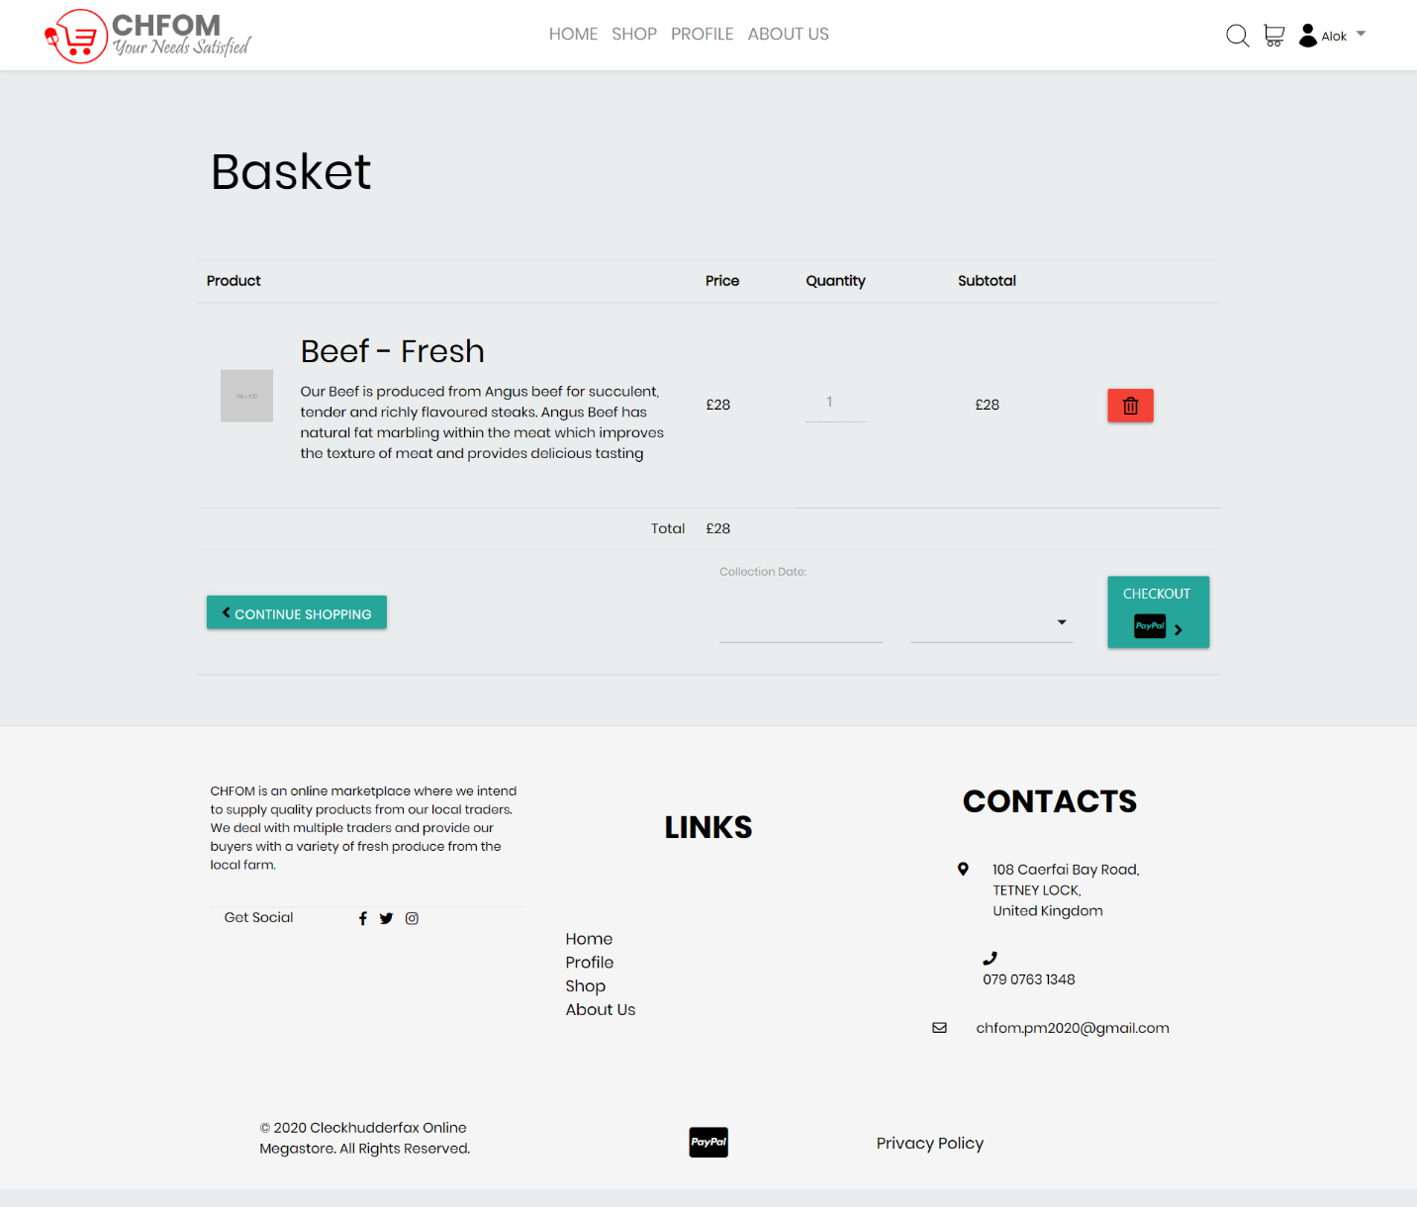

## Customers can make payment for the whole basket at once

Expected Result: Payment is made

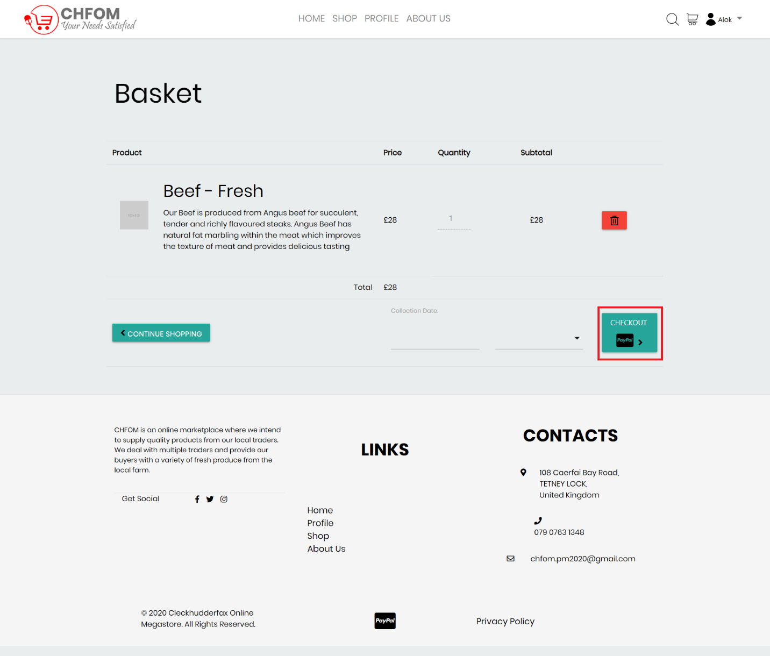

## Customers will receive a receipt of payment for their goods in their email once payment is confirmed

Expected Result: The customer receives the invoice/receipt